***Name: Tabammum Haque Pranty***

***SQA Assignment-04***

Here are the 7 phases of the Software Development Life Cycle (SDLC) with some tasks:

**Planning Phase:**

- Define project scope and objectives.

- Identify stakeholders.

- Develop a project plan and timeline.

- Estimate project resources and budget.

- Risk Assessment

**Analysis Phase:**

- Gathering requirements.

- Understand Business Needs

- Define System Requirements

- Identify Constraints

- Document use cases and user stories.

- Review requirements with stakeholders for validation.

**Design Phase:**

- Create high-level system architecture and design.

- Develop detailed database design and schema.

- Design user interfaces (UI/UX).

- Prepare data flow diagrams (DFDs) and entity-relationship diagrams (ERDs).

- Establish technical standards and tools for development.

**Implementation Phase:**

- Write code based on design specifications.

- Integrate different system modules.

- Conduct unit and module testing.

- Maintain version control for code.

- Update technical documentation as code progresses.

**Testing Phase:**

- Develop and execute test cases and scenarios.

- Perform various types of testing (unit, integration, system, UAT).

- Log defects and track resolution.

- Conduct performance and security testing.

- Obtain user feedback and validate results.

- Test Planning and Execution

- Defect Reports

**Deployment Phase:**

- Prepare the production environment.

- Deploy the system to the live environment.

- Migrate data from old systems if necessary.

- Provide user training and documentation.

- User Support

- Feedback Collection

- Monitor initial use and address any immediate issues.

**Maintenance Phase:**

- Provide ongoing technical support.

- Monitor system performance and usage.

- Apply patches and software updates.

- Perform system enhancements based on feedback.

- Document and resolve bugs or defects.

**Bug Finding for a Website:**

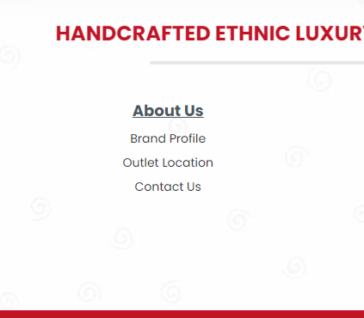

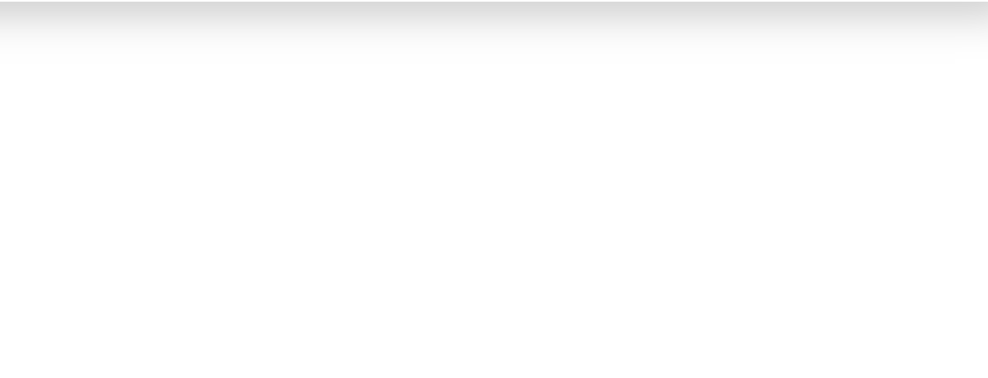

**In this picture, If I click on contact us, it doesn’t show the information whereas I can see the information through mobile app.**

**URL:** [**https://www.deshal.net/**](https://www.deshal.net/)